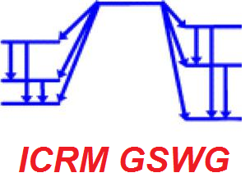
Registration form
Meeting of the ICRM Gamma Spectrometry Working Group
October 29-30, 2020 from 12:00 to 15:00 UTC (13:00 to 16:00 CET)
Virtual meeting (connection link will be sent to registered partipants)

Last Name: _
First Name: _
Institute: _
E-mail: _
Phone: _
Postal address: _
_
_

I plan to make a presentation _ YES _ NO
If YES, please give title(s): _
_
_
and desired presentation duration (typically between 10 and 20 minutes): _

Specific topic(s) to include in the discussion: _
_
_

Web Platform Software Limitations (if any): _

